Snowflake Free Trial: Step-by-Step Signup Guide
This guide walks participants through creating a free Snowflake trial account — the required first step before joining any Snowflake hands-on lab. The trial is completely free, requires no credit card, and includes $400 in free credits valid for 30 days.[^{1][}2]

What You Get with the Free Trial
- $400 in free Snowflake credits — equivalent to substantial compute and storage usage[^1]
- 30-day access — full platform access from signup date[^3]
- Enterprise Edition features — multi-cluster warehouses, materialized views, Time Travel up to 90 days, and more[^4]
- Pre-provisioned learning environment — a snowflake_learning role, warehouse, and database ready to use immediately after login[^3]
- Access to Snowflake Marketplace — 150+ public domain datasets available at no extra cost[^5]

Step 1: Navigate to the Signup Page
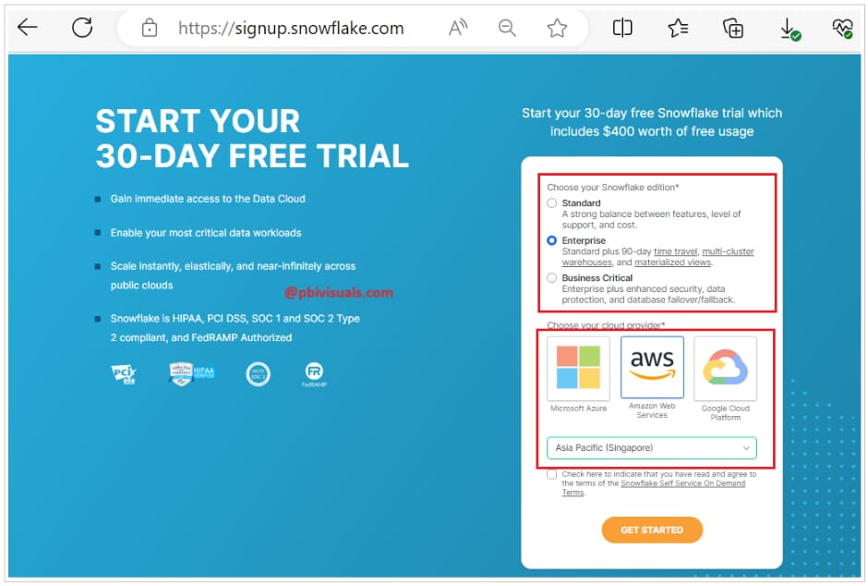
Snowflake free trial signup page
Open a browser (Chrome is recommended) and go to:
https://signup.snowflake.com
You will land on the Snowflake free trial registration page.[^6]
Step 2: Enter Your Personal Details
Fill out the registration form with the following information:[^7]
- First Name and Last Name
- Work or personal email address — this will be used to activate your account and log in
- Company name — you can enter "Self" or any organization name for learning purposes
- Country or region — may be auto-detected based on your location
No mobile number is required.[^7]

Step 3: Choose Your Cloud Platform
Select one of three cloud providers to host your Snowflake account:[^{7][}3]
Provider | Recommended For
AWS (Amazon Web Services) | Default choice; recommended for most labs[^{1][}7]
Azure (Microsoft) | Preferred if your organization uses Azure
GCP (Google Cloud Platform) | Preferred if your organization uses GCP

Important: Your cloud provider cannot be changed after account creation. If you need a different provider later, you will need to create a new trial account.[^3]

Step 4: Select Your Region
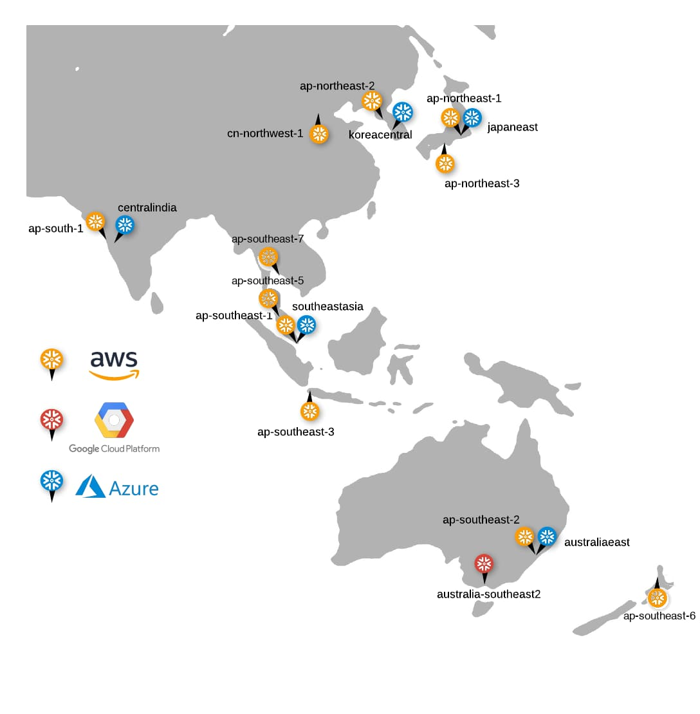
Supported cloud regions map
After choosing a cloud provider, select the cloud region closest to your physical location. Choosing a nearby region ensures the best query performance during the lab.[^4]
- The platform may auto-select a region based on your IP address[^7]
- For most North America-based participants using AWS, US West (Oregon) or US East (N. Virginia) are common choices[^8]
Important: Like cloud provider, region cannot be changed after account creation.[^3]

Step 5: Select Your Snowflake Edition
Snowflake offers multiple editions. For hands-on labs, Enterprise is strongly recommended:[^{4][}5]
Edition | Key Capabilities
Standard | Core features, Time Travel up to 1 day
Enterprise ✅ Recommended | Multi-cluster warehouses, materialized views, Time Travel up to 90 days, column-level security[^4]
Business Critical | Highest security/compliance, HIPAA support

Select Enterprise to ensure all lab exercises work as expected, including advanced features like multi-cluster warehouses and extended Time Travel.[^{5][}4]

Step 6: Accept Terms and Submit

Snowflake free trial signup
- Check the box to accept Snowflake's Terms of Service
- Click "Get Started" (or equivalent submit button)[^7]
You will see a confirmation screen indicating your signup is complete.
Step 7: Activate Your Account via Email
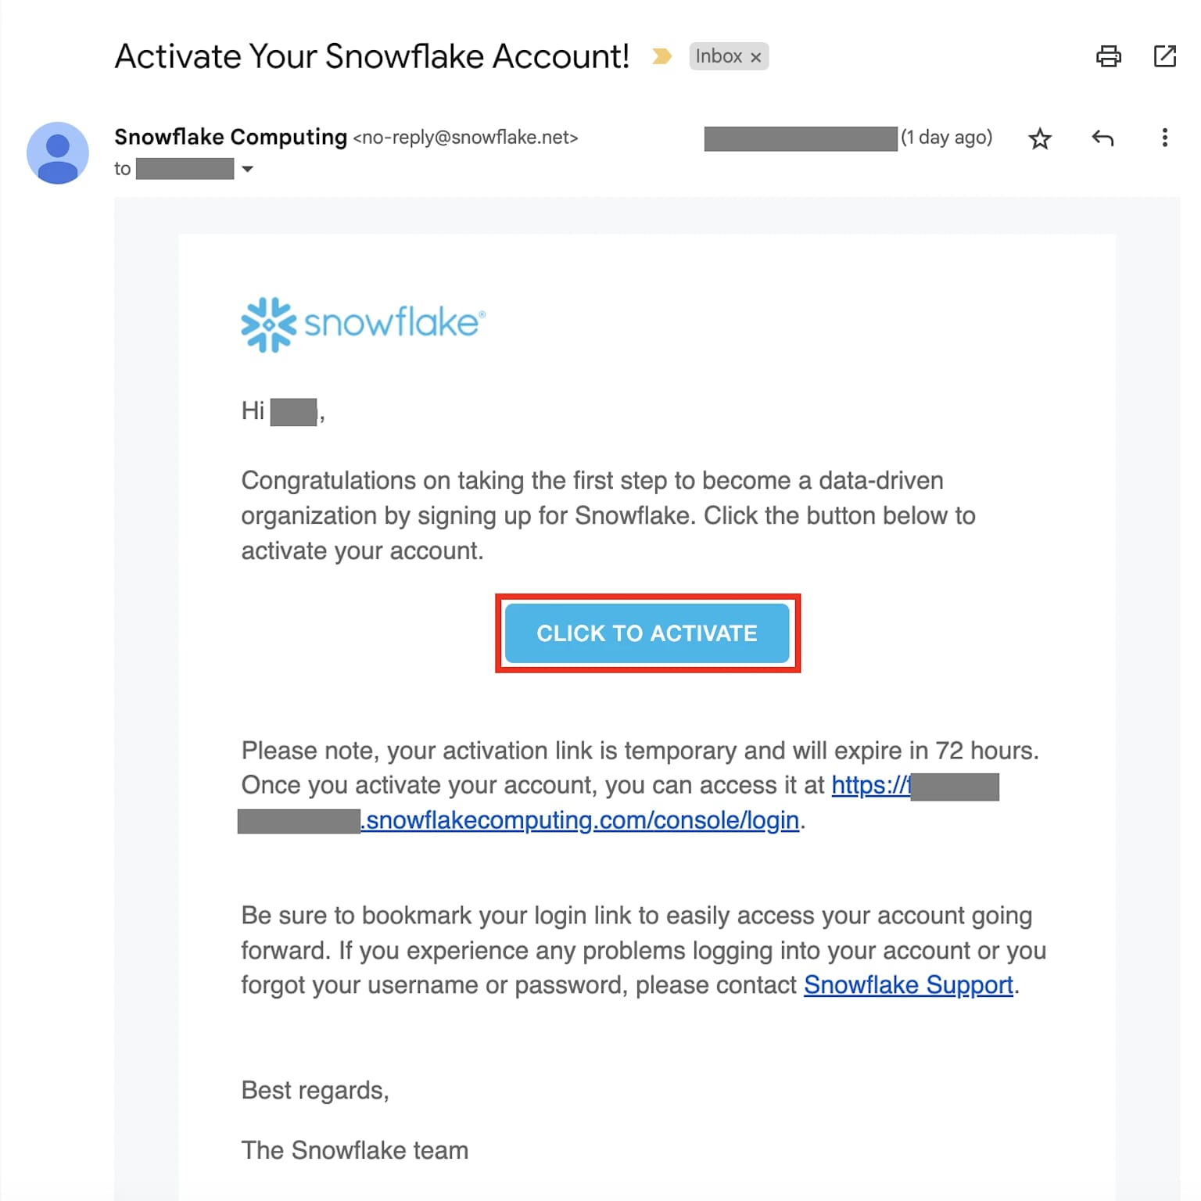
Snowflake account activation email
Within a few minutes, you will receive an activation email from Snowflake.[^4]
- Check your inbox for an email from Snowflake
- If not found, check your spam or junk folder[^3]
- Click the "Click to Activate" button in the email[^7]
If you don't receive the email after several minutes, verify the email address you entered during signup and try requesting a new activation email. Corporate email filters may block Snowflake emails — ask your IT department to whitelist Snowflake email domains if needed.[^3]

Step 8: Create Your Username and Password

Snowflake sign-up form
After clicking the activation link, you are taken to the account setup page:[^{7][}4]
- Choose a username (this is your Snowflake login name — save it)
- Set a strong password
- Click "Get started" or the equivalent confirmation button

Step 9: Log In to Snowsight
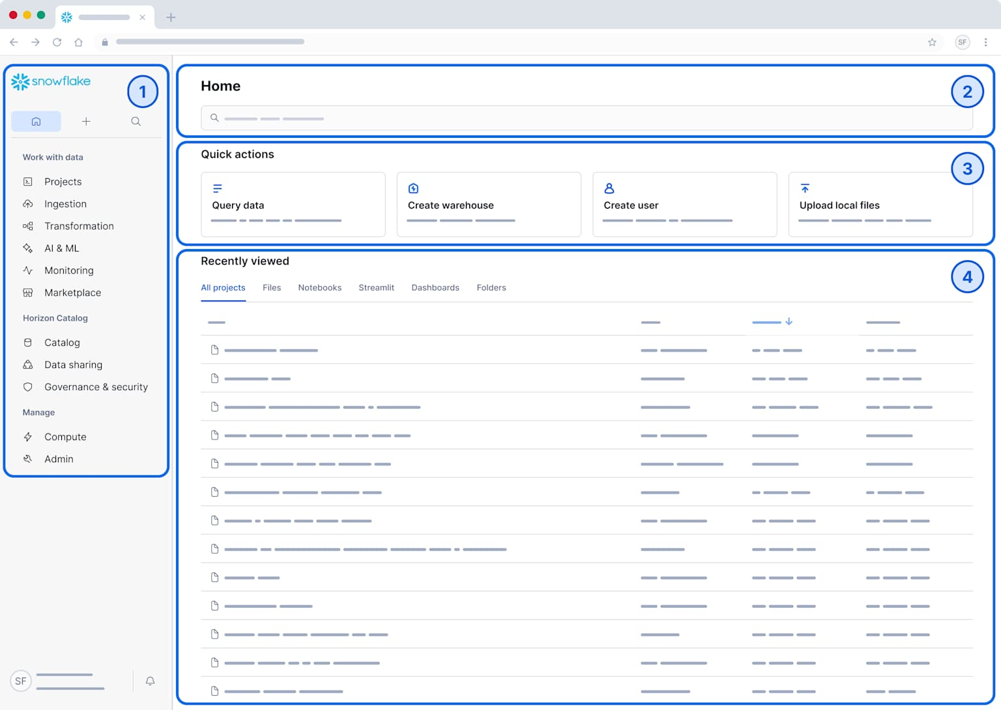
Snowflake Snowsight interface
After completing account setup, you are automatically logged into — or redirected to — Snowsight, Snowflake's web-based UI.[^7]
You can also log in at any time by navigating to:
https://app.snowflake.com
Enter the account URL that was included in your activation email (bookmark this for easy future access), along with your username and password.[^4]
Step 10: Explore Your Trial Environment
Once logged in, your Snowflake trial environment is ready. Key areas to familiarize yourself with before the lab:[^3]
Area | Location in Snowsight | Purpose
Worksheets | Projects > Worksheets | Write and run SQL queries
Notebooks | Projects > Notebooks | Python/SQL notebook environment
Warehouses | Admin > Warehouses | Manage compute resources
Databases | Data > Databases | View and manage data objects
Marketplace | Data Products > Marketplace | Access free external datasets
Cost Management | Admin > Cost Management | Monitor credit usage

A pre-provisioned COMPUTE_WH virtual warehouse and default databases are available in your account from the moment you log in.[^5]

Trial Limitations & Tips
- Credits are consumed whenever a virtual warehouse is running, even if no queries are actively executing — warehouses auto-suspend after inactivity to save credits[^6]
- Do not set warehouses to 4X-Large or run them without auto-suspend during the lab, as this burns through credits quickly[^5]
- Some features (e.g., external network access, hybrid tables) have limited daily credit usage until a payment method is added[^3]
- The trial account is suspended at the end of 30 days or when credits are exhausted — add a credit card under Admin > Billing to convert to a paid account and preserve your data[^3]
- You can create multiple trial accounts using different email addresses if you need a fresh environment[^9]

Quick Reference
Item | Value
Signup URL | https://signup.snowflake.com
Login URL | https://app.snowflake.com
Trial duration | 30 days from signup
Free credits included | $400
Credit card required? | No
Recommended edition | Enterprise
Recommended cloud | AWS
Pre-event setup deadline | At least 24 hours before a live lab[^10]

References
- Snowflake Free Trial Setup 2026: Create Account & Snowsight UI Tour in Minutes! ❄️ Hands-On - ❄️ Snowflake Account Setup 2026 – Get Started with FREE Trial & Snowsight UI! 🚀
Namaste friends! In ...
- Snowflake's Use of Cookies
- Snowflake Trial: Build AI & Apps in Minutes - Use sample data and a pre-provisioned snowflake_learning role, warehouse and database to quickly exp...
- Early Access To New Releases - The document outlines a comprehensive agenda for setting up and using a Snowflake trial account, inc...
- Free Virtual Hands-on Lab
- Snowflake Hands-on Lab: Working with Snowflake Basics - 🔹 Lab Prerequisites
- Snowflake Explained | Sign up - Snowflake Trial Account (Masterclass Ep.2) - Welcome to Episode 2 of the Snowflake Masterclass Series!
In this quick 5-minute tutorial, we’ll ex...
- Snowflake Hands-On Essentials Track — Badge 1: Data Warehousing Workshop — Study Note - Lesson 1: Getting Set Up
- How to Leverage Snowflake (Trial) Account for Multi-Platform, Multi-Region and Multi-Edition… - No more dealing with multiple Snowflake trial accounts
- Snowflake Virtual Hands-on Lab | Snowflake Data Cloud - Join our instructor-led virtual hands-on lab to learn how to get started with Snowflake. Find a hand...

